Robert Minson

SYS-400

October 28, 2022

Prof. Dilts

Storage, Indexing, and Views

1. When running queries in your database, your results may come back slowly. This could be a result of creating the indexes incompetently, inadequately designed database plan, and not enough storage in your I/O subsystem. The index issue could be resolved by executing the indexes you suspect are bad (West, 2019). The database will hold how it loaded it and you can go check that to see if it is your issue (West, 2019). The database plan can be solved by running SQL Profiler (West, 2019). When you run the profiler, it will tell you what is creating a high I/O load (West, 2019). Finally, to fix the storage problem, find the problem by “running sys.dm_os_wait_stats DMV” (West, 2019). Those are just a few ways that your results may be coming back slowly and how to treat those issues.
2. Indexing can also cause issues that can negatively affect your database as well though. Two of those issues could affect the speed of both writes and selects (Gravell, 2019) it as well could force the use of more hardware resources then is necessary (Petrovic, 2014). The first issue could occur when you have an improperly built index that is both calling on columns and writing into them in a way it is pulling from so many tables that it can not efficiently do the task. The second issue could happen you are using multiple indexes that have to pull from tables in an odd order forcing your memory and the threads of your processors to work overtime to accomplish the task. So while indexing can lead to saving a lot of time in your database, it can also lead to a few negative side effects if done improperly.
3. Graphical user interface, application

   Description automatically generated

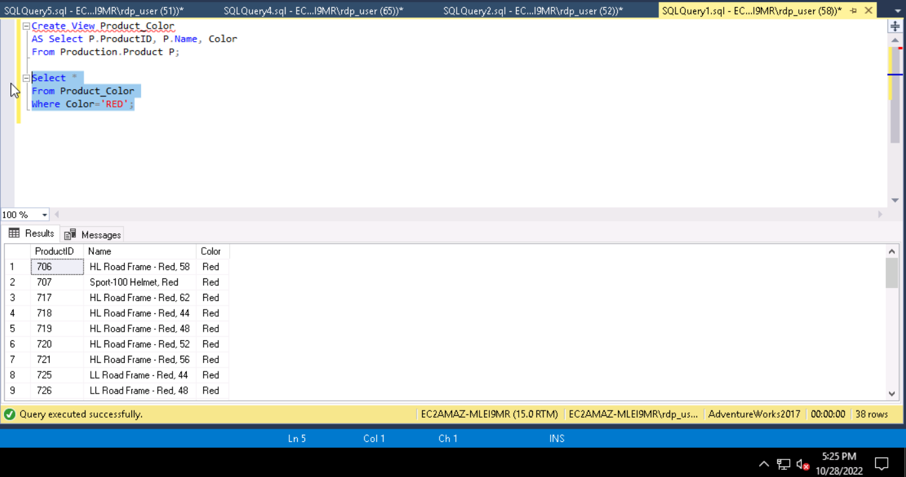

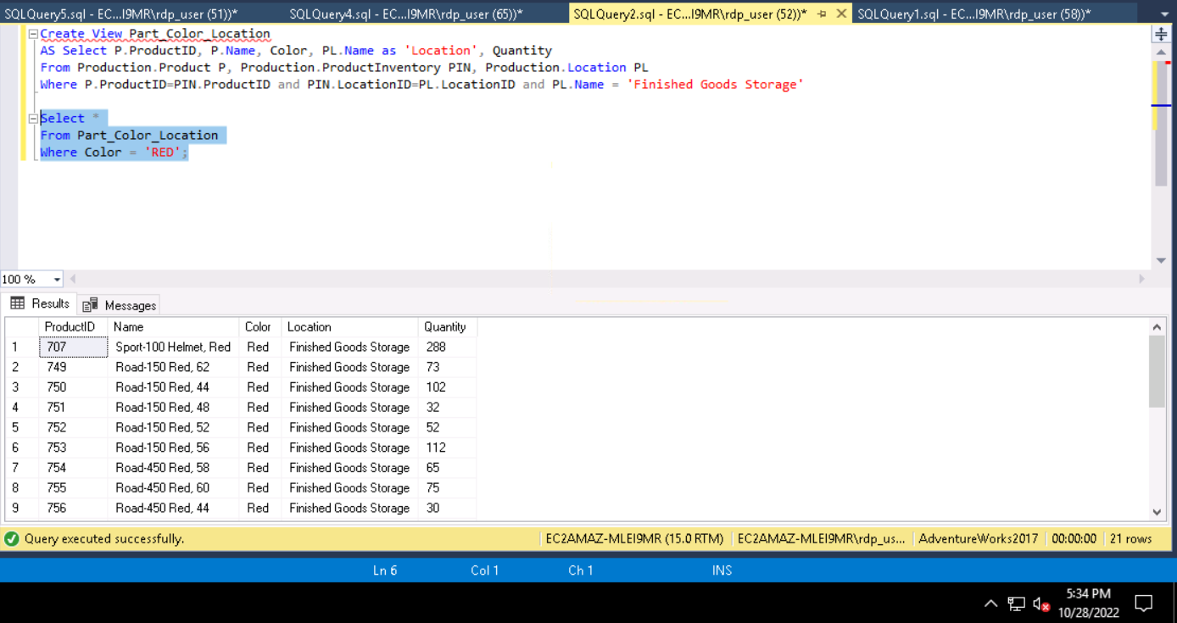

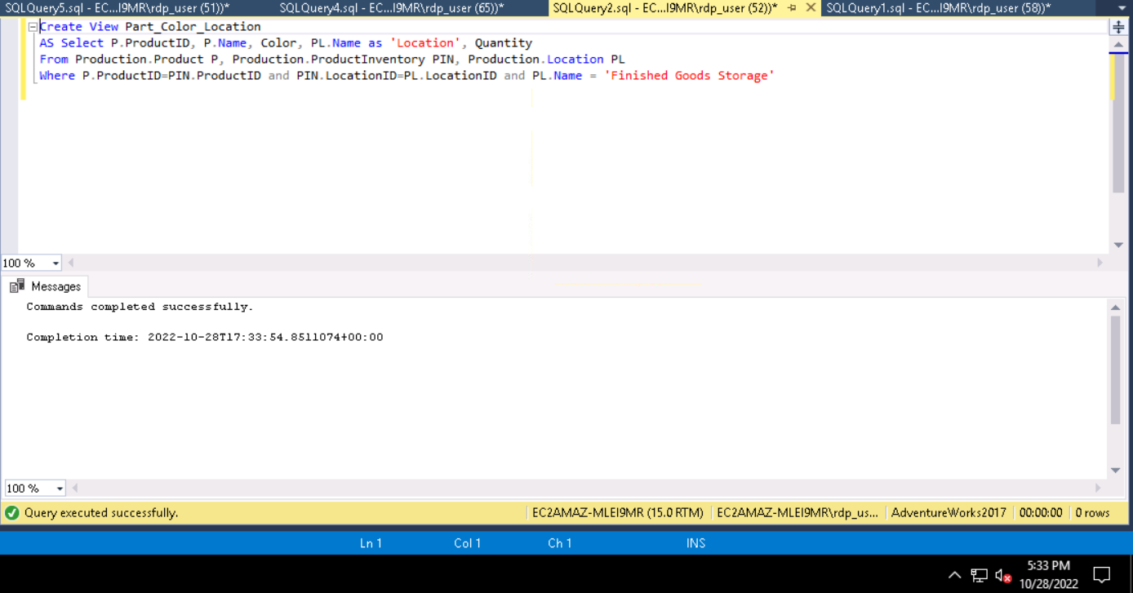

REFERENCES

Gravelle, Robert. (2021, August 9). *The downside of database indexing.* Navicat.

<https://www.navicat.com/en/company/aboutus/blog/1764-the-downside-of-database-indexing#:~:text=The%20Effects%20of%20Poor%20Indexing&text=If%20indexes%20are%20not%20created,fetching%20the%20data%20take%20longer>

Petrovic, Milena. (2014, April 14). *Poor database indexing a SQL query performance killer*

*Recommendations.* SQL shack. <https://www.sqlshack.com/poor-database-indexing-sql-query-performance-killer-recommendations/>

West, Stephen. (2019, February 26). *Tips to improve performance of slow running SQL server.*

SQL server log explorer. <https://www.sqlserverlogexplorer.com/improve-performance-slow-running-sql-server/>